BCS 370

Team #6

Group Writeup

1. The members for our team are Nicholas Poje, Michael Vardanian, and Anthony Weathers.
2. 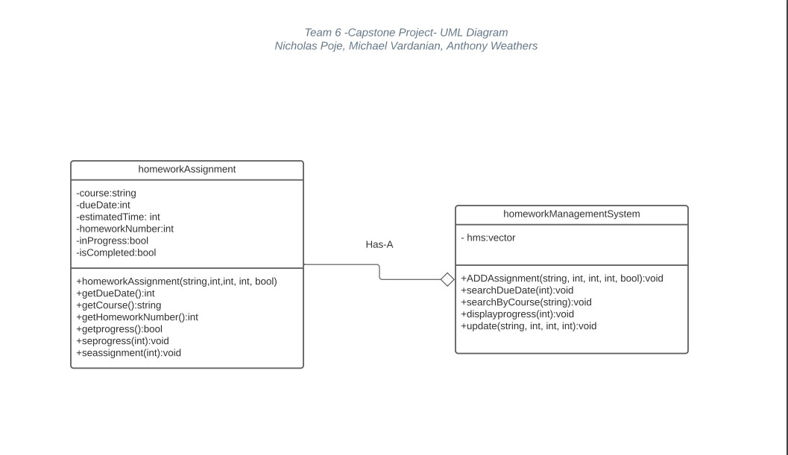
3. The data structure we chose to use is a vector. We used this data structure because it is dynamically allocated and is able to store reference types, which are homework assignments in our project. Homework assignments are able to be added as needed and can be easily accessed due to the nature of this data structure.

The method we decided to implement with tail recursion is the displayProgress method. When this method is selected from the menu of the homework management system, an int equal to 0 is input to the method. The method will check that index of the vector to see if the assignment stored there is in progress. If it is, the course, homework number, and days due for that assignment is output to the console. The tail recursion works by calling itself with the int incremented by 1. The base case stops this recursion once all assignments have been checked, which is when the int is equal to the size of the vector.

The complexities of the searchByDueDate and searchByCourse methods are both O(n). This is the case because both methods utilize a for loop that traverses the length of the vector. It will check every assignment to see if it has the same due date or course name that was input to the method.